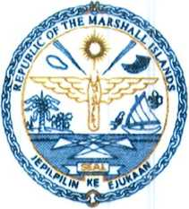

Republic of the Marshall Islands

Ministry of Finance, Banking and Postal Services  
Division of International Development Assistance

**P.O. Box D Majuro Marshall Islands 96960**

**Phone No. (692) 625-5968/8311**

**Website: rmi-mof.com**

*AUGUST9, 2019*

To the attention of the GAFSP Coordination Unit,

**Subject:** Submission of the Multi-Country Proposal for the **Small Islands Food and Water Project (SIFWaP)**

I write to you in reference to the GAFSP Special Call for Proposal for Fragile and Conflict Affected Countries - Public Sector Window, of March 14, 2019.

I am pleased to submit to your attention the multi-country proposal for the **Small Islands Food and Water Project** (SIFWaP) to be implemented in the Republic of the Marshall Islands, the Federated States of Micronesia, Kiribati and Tuvalu.

With this letter, I hereby confirm that the Ministry' of Finance, Banking and Postal Services of the Government of the Republic of the Marshall Islands:

* selects the International Fund for Agricultural Development (IFAD) as the Investment Supervising Entity and the Food and Agriculture Organization of the United Nations (FAO) as additional supervising entity for Technical Assistance; and
* authorises IFAD to submit the attached proposal on behalf of the Ministry.

Sincerely,

Brenson S. Wase

Minister of Finance, Banking & Postal Services

